Record Data
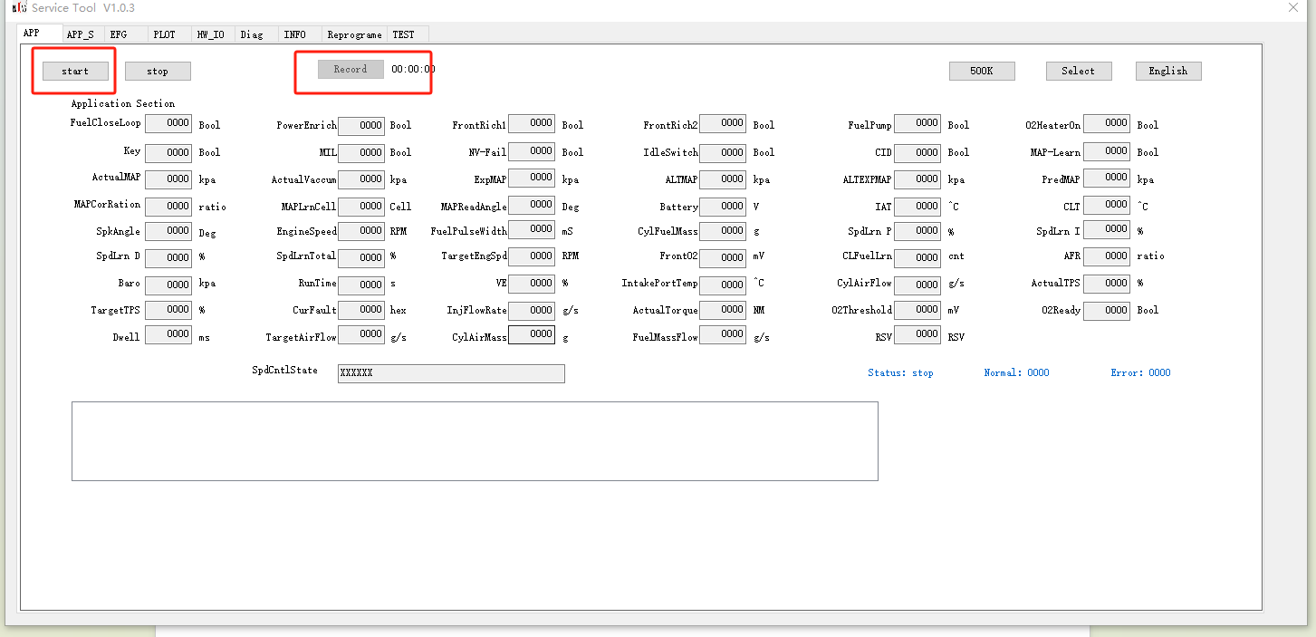

The data file is in the record folder of the same directory as the application
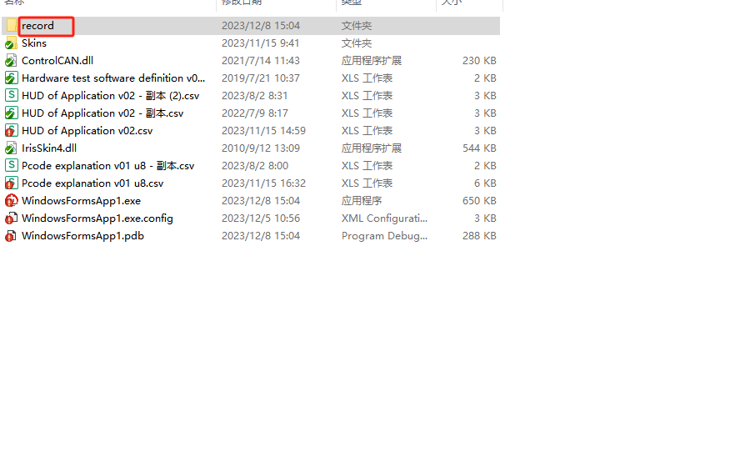

Show Data

- select file
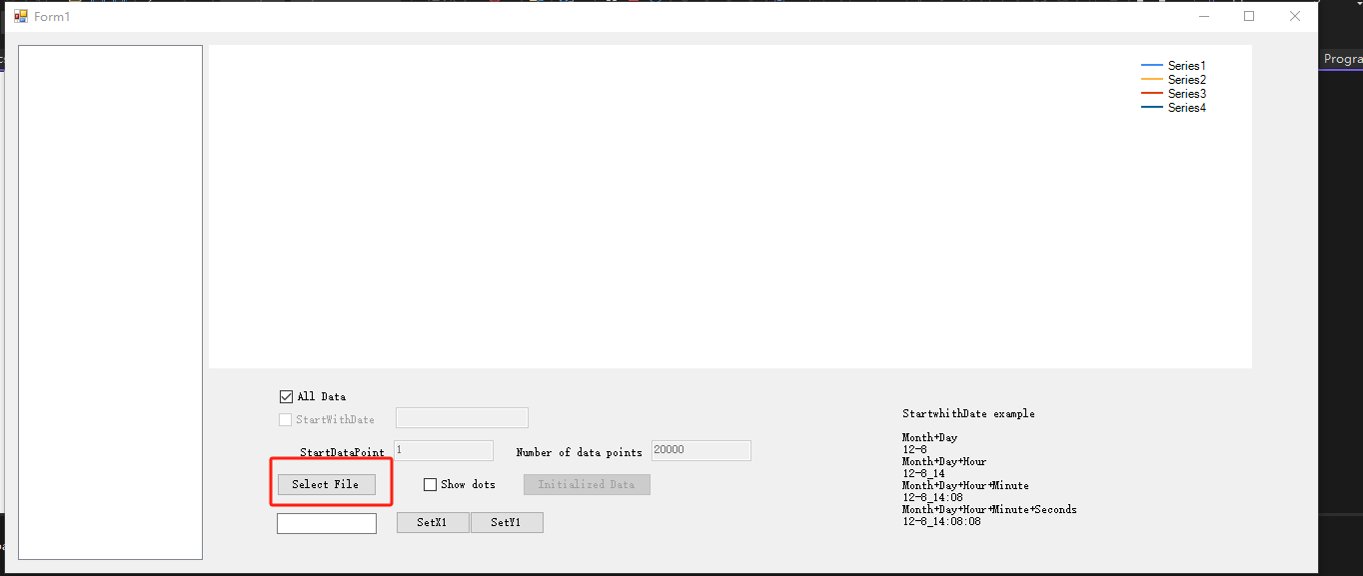
- Check the file name and select Items
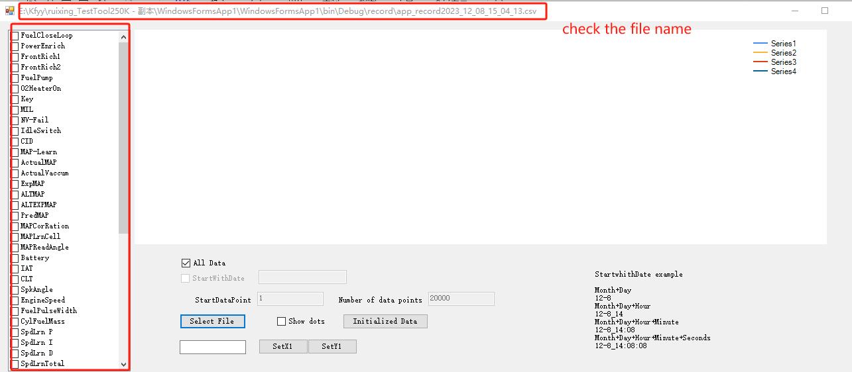
- Set chart parameters
If the file is small, select all data
If the file is too large, it will consume a lot of memory and cause lag. At this point, it is recommended to only display partial data,
You can locate and modify the data to be displayed based on time or data points
- Load data
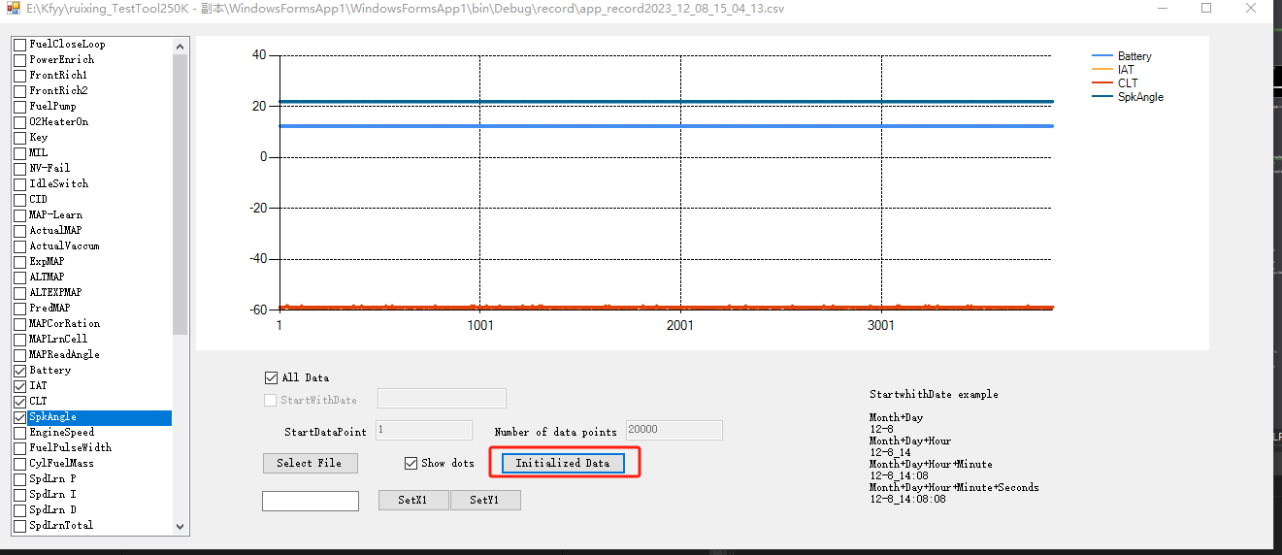
- Set XY to change chart size
